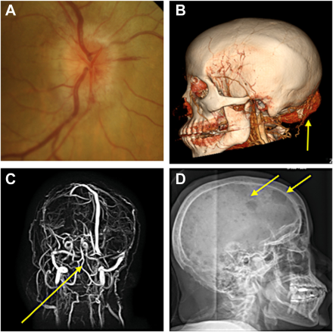

A 62-year-old healthy woman presented with 2 recent painless episodes of vision loss lasting 20 seconds each in her right eye. Fundusexamination revealed right (A) greater than left optic disc edema without retinal ischemia. Neuro-imaging demonstrated a large occipitalmass (B) and severe torcula and bilateral transverse venous sinus compression without thrombosis (C). Osteolytic skull lesions (D). Based on the provided images and clinical description please make an ophthalmic diagnosis for this patient. And output the diagnostic conclusions only.

**Bilateral optic disc edema (papilledema), more prominent in the right eye, secondary to increased intracranial pressure due to an occipital mass and associated venous sinus compression, likely related to metastatic disease given the osteolytic skull lesions.**